**DSP LAB EXPERIMENT – 3**

**Aim**: To study the spectral components of an audio and voice signal.

A) Consider a set of synthetic composite signal with a minimum of 10 harmonics in the audio range. Observe each component individually and study the resultant signal.

B) Choose a set of suitable real data for comparative analysis, write a sample script to validate the claims. Also select a set of signals with unknown spectrum and compare their corresponding spectra.

**Solution:** In the part A I am considering a signal sin(2*pi*f*t). For the harmonics, I am starting the frequency at 50Hz and taking it till the 10th Harmonic with 230Hz.

**Code/Script:**

clc;

close all;

fs=44100;

dt = 1/fs;

ST = 1; %Stop Time

t = (0:dt:ST-dt)';

%Part A i):

% Analysis of 10 harmonics starting with

%f=50Hz with an interval of 20Hz.

g1=sin(2*pi*50*t);

plot(t,g1);

figure;

g2=sin(2*pi*70*t);

plot(t,g2);

figure;

g3=sin(2*pi*90*t);

plot(t,g3);

figure;

g4=sin(2*pi*110*t);

plot(t,g4);

figure;

g5=sin(2*pi*130*t);

plot(t,g5);

figure;

g6=sin(2*pi*150*t);

plot(t,g6);

figure;

g7=sin(2*pi*170*t);

plot(t,g7);

figure;

g8=sin(2*pi*190*t);

plot(t,g8);

figure;

g9=sin(2*pi*210*t);

plot(t,g9);

figure;

g10=sin(2*pi*230*t);

plot(t,g10);

%The part A i) was for plotting the graphs

%This is part A ii) where we listen to the harmonics.

disp("Playing Sound 1")

soundsc(g1,fs);

pause;

disp("Playing Sound 2")

soundsc(g2,fs);

pause;

disp("Playing Sound 3")

soundsc(g3,fs);

pause;

disp("Playing Sound 4")

soundsc(g4,fs);

pause;

disp("Playing Sound 5")

soundsc(g5,fs);

pause;

disp("Playing Sound 6")

soundsc(g6,fs);

pause;

disp("Playing Sound 7")

soundsc(g7,fs);

pause;

disp("Playing Sound 8")

soundsc(g8,fs);

pause;

disp("Playing Sound 9")

soundsc(g9,fs);

pause;

disp("Playing Sound 10")

soundsc(g10,fs);

pause;

%Part A iii):

%Here, we combine all the graphs for different harmonics to get a single

%graph.

g=g1+g2+g3+g4+g5+g6+g7+g8+g9+g10;

plot(t,g);

figure;

%Part B:

%Here, we start with using fftshift function of Matlab. fftshift swaps the

%values of left and right halves of the vector in a x-y graph. Here, the

%vector is g.

ft=fftshift(fft(g));

t = (0:dt:ST-dt)';

N = size(t,1);

dF = fs/N;

f = -fs/2:dF:fs/2-dF;

plot(f,abs(ft));

%Analyzing the sound of Airplane Landing:

disp("Playing Cat Meow Sound")

xlim([-250 250]) % This sets the limit for the x-axis.

[als,fs]=audioread('Cat_Meow_2-Cat_Stevens.mp3');

left=als(1:N,1);

partb = fftshift(fft(left));

figure(13);

plot(f,abs(partb)/N);

xlim([-7000 7000])

soundsc(left,fs)

pause;

%Analyzing my own voice clip

disp("Playing My Voice Clip")

[mvs,fs]=audioread('DSP_Lab_3_file.m4a');

left=mvs(1:N,1);

partb = fftshift(fft(left));

soundsc(left,fs);

figure(14);

plot(f,abs(partb)/N);

xlim([-4000 4000])

pause;

**Output: 1.) Base Frequncy: 50Hz  
  
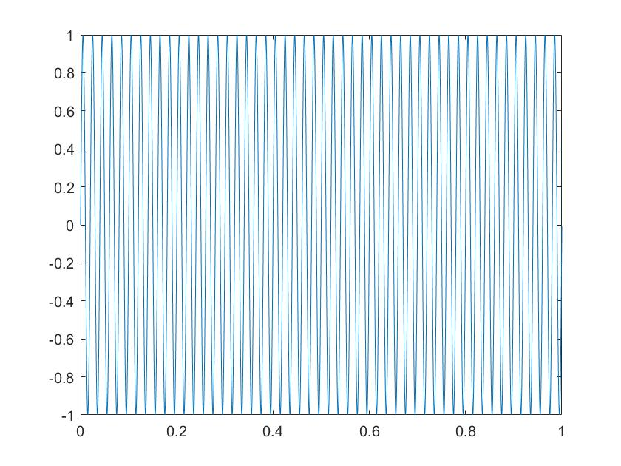**

2.) Harmonic 2: 70Hz

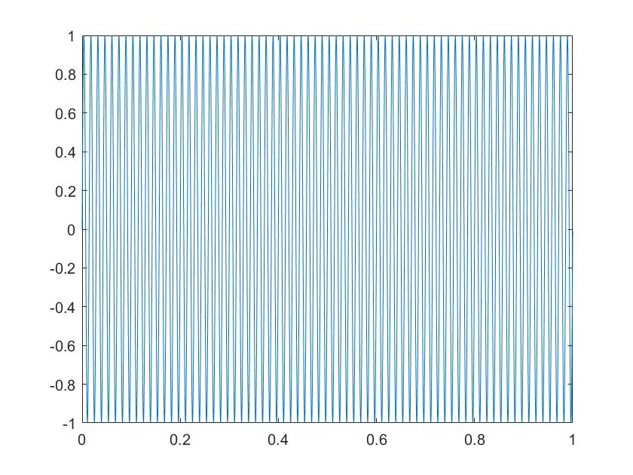

3.) Harmonic 3: 90Hz

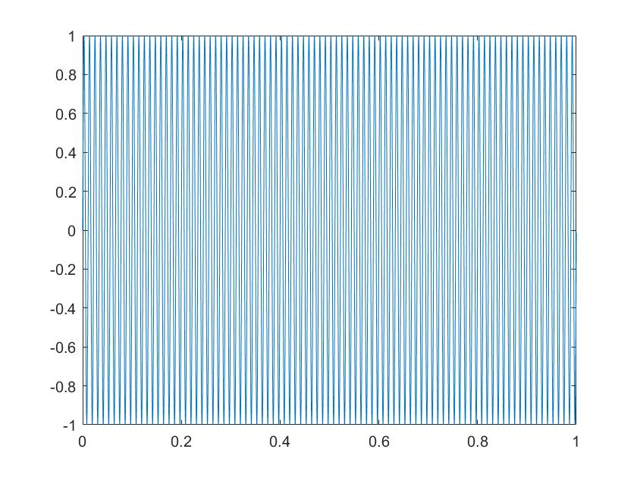

4.) Harmonic 4: 110Hz

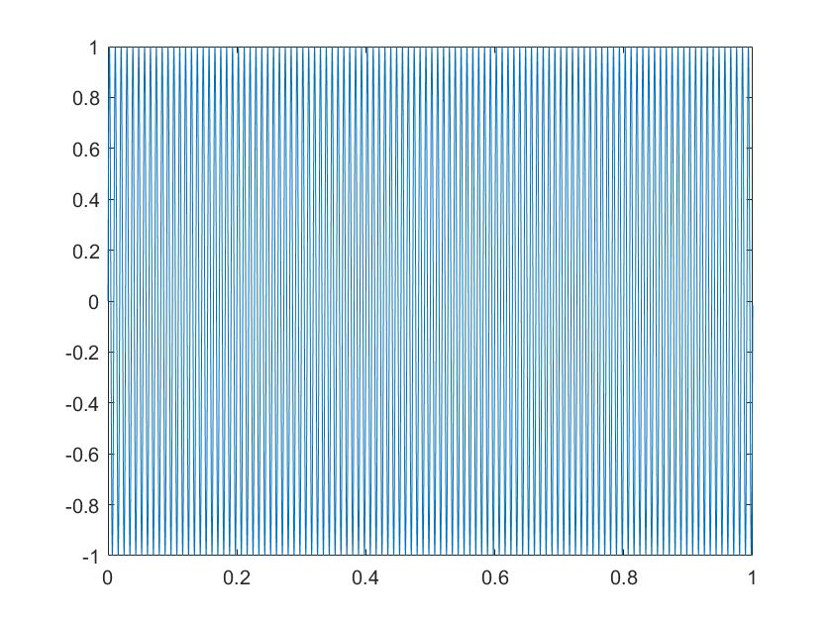

5.) Harmonic 5: 130Hz

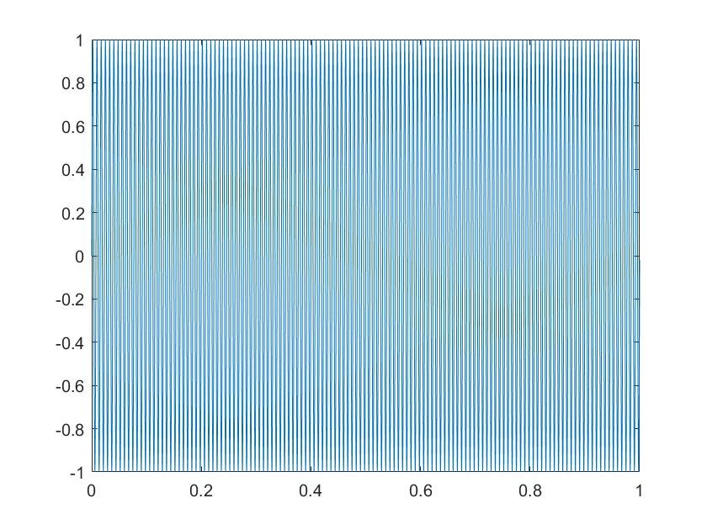

6.) Harmonic 6: 150Hz

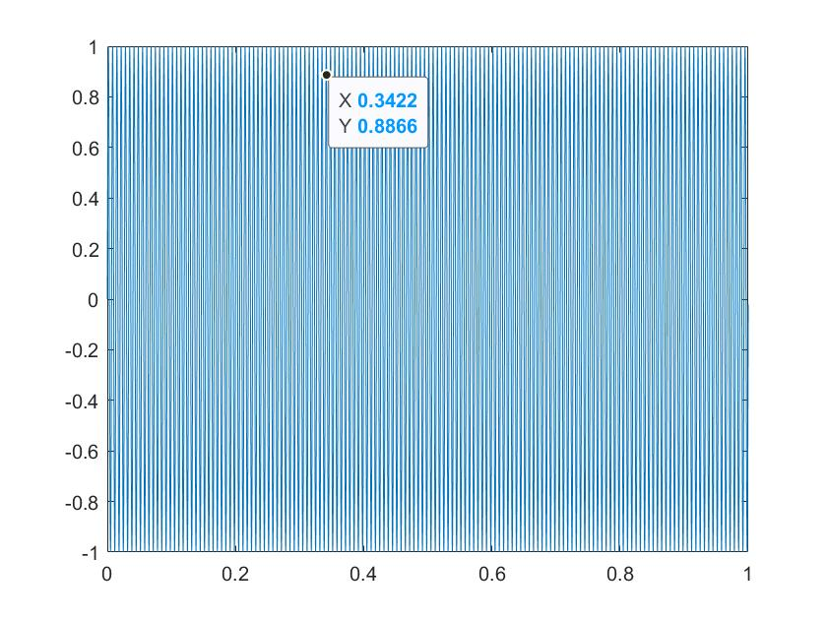

7.) Harmonic 7: 170Hz

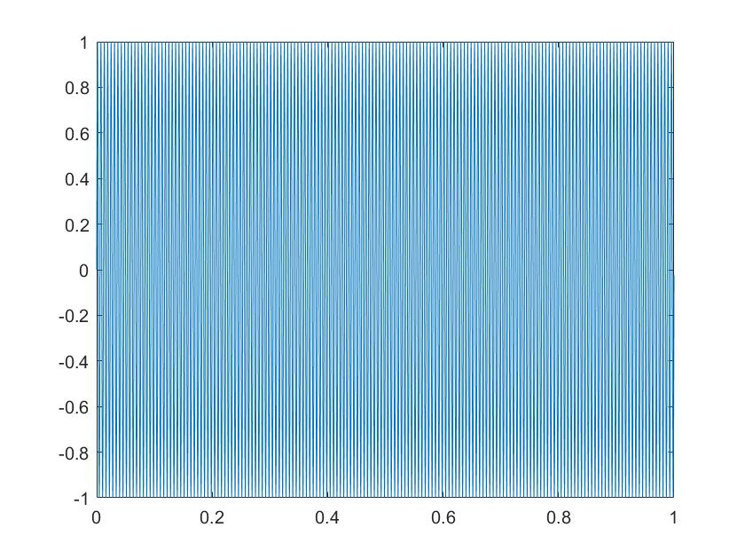

8.) Harmonic 8: 190Hz

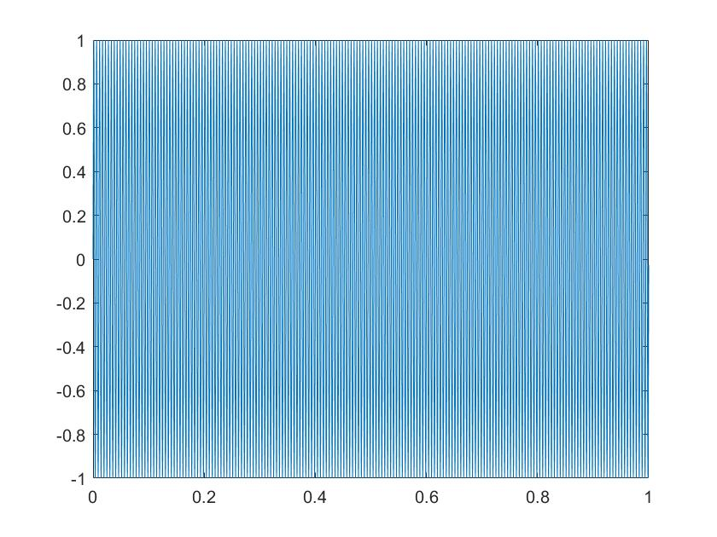

9.) Harmonic 9: 210Hz

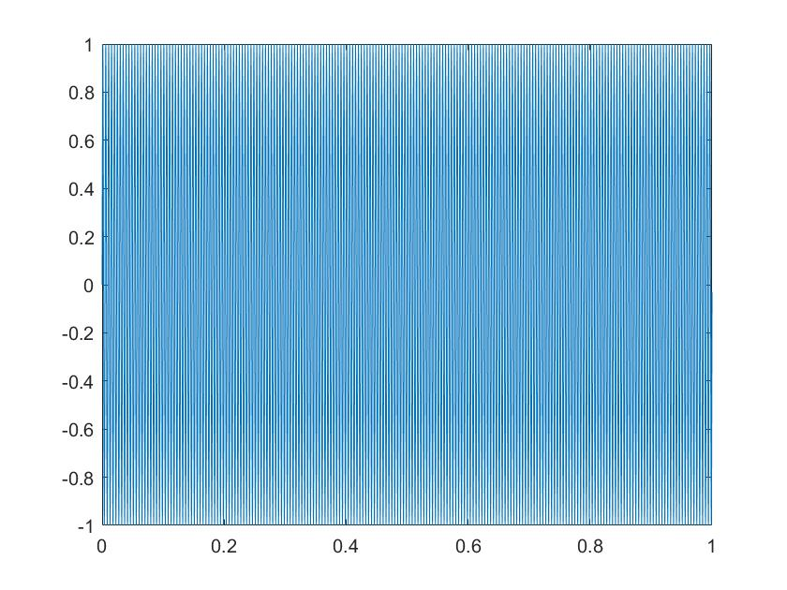

10.) Harmonic 10: 230Hz

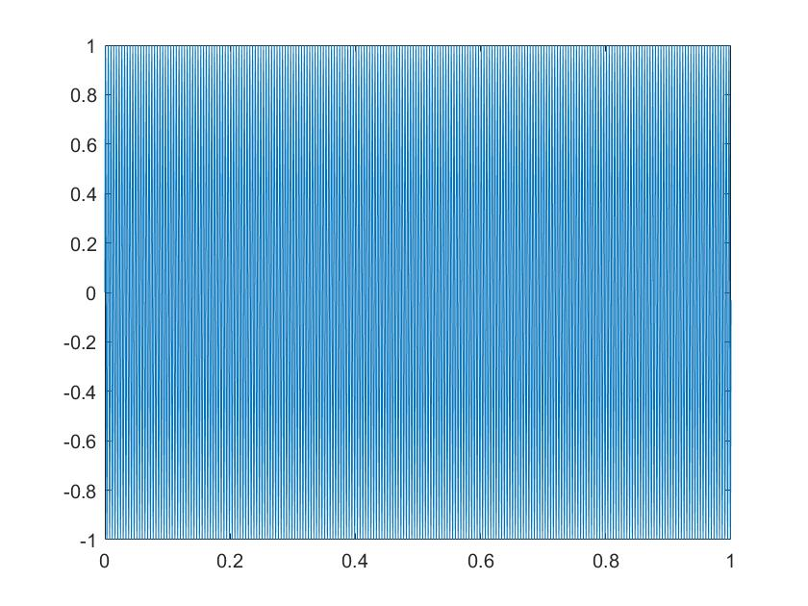

**Signal Output:**

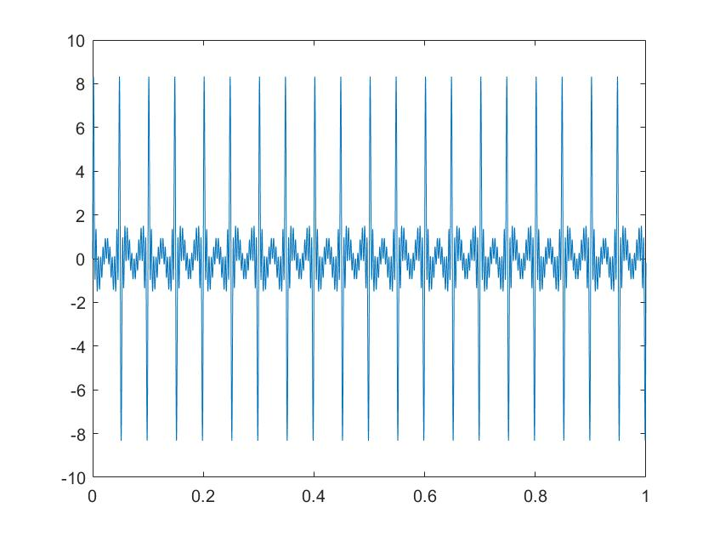

**Frequency Response of the signal Output:**

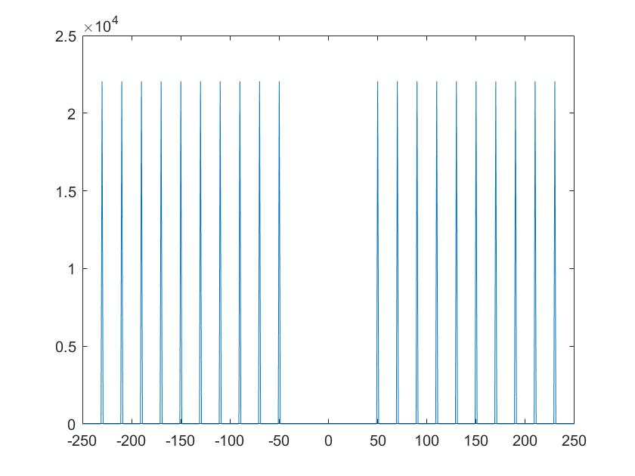

Part B)

Cat Meow Sound (Spikes observed in 0-6000Hz range):

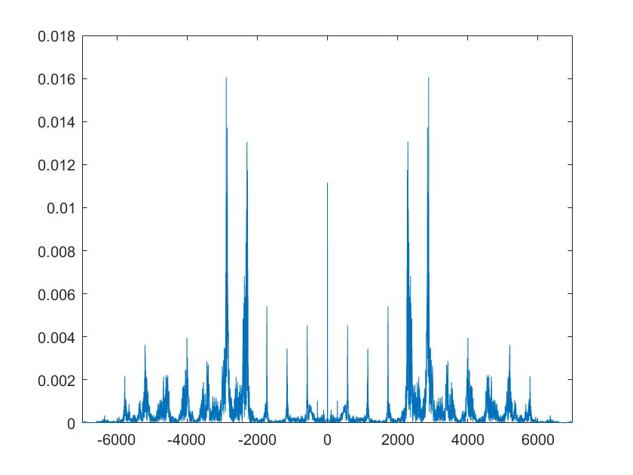

**My Own Voice Clip:**

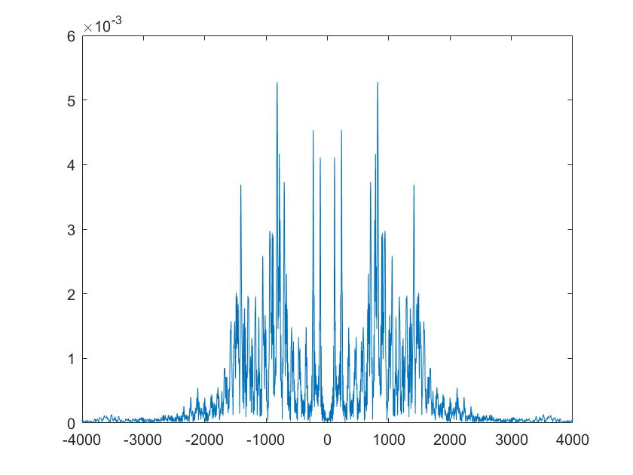

**Conclusion:**

**Part A)**

Here, there were no noise components seen in all the graphs for 10 harmonics. As the frequency increases, it starts to shrink and apparently it looks to our eyes like a grid. The sound waves start getting sharper and dense. It happens because the signal is synthetically produced.  
The plot of summation of all the g1 to g10 harmonic graphs shows peaks of equal amplitude on both sides. Here also, there are no noise components.

**Part B)**

Here we observed signals from the real world. The signals weren’t produced synthetically like in Case A. Therefore, there were many noise components in the output waveform. It was a mixture of various frequencies. Cat Meow Sound (Spikes in 0-6000Hz Range) was outside the vocal range and it was a audio signal. And in my own voice clip, the spikes were dominant in the range 0-2000Hz, i.e., they are the noise components.  
  
Hence, we observed that synthetically produced signal is pure in a sense that noise components are noticeably negligible than the audio sound or natural sound in which noise is predominantly visible.